CHAPTER 2 — METHODOLOGY

2.1 Research Design / Project Development Methodology
This study employs a developmental research design (design-and-development research) suited to information technology and computer science projects that produce an artifact rather than only test a hypothesis. The research proceeds through iterative cycles of requirements analysis, architectural design, prototype implementation, controlled testing, evaluation, and revision, because a low-cost marine monitoring platform can only be judged when its buoy, sensing, communication, and energy subsystems are engineered and evaluated as one integrated unit (Williams et al., 2025; Rojas et al., 2025).
The study is applied experimental development: the artifact — a solar-powered coastal observation buoy paired with a shore-based Bay Station — is built and then subjected to controlled trials that yield quantitative evidence of measurement quality, communication reliability, power autonomy, security behavior, usability, and short-term prediction accuracy. Consistent with the caution that every observing platform and processing method carries its own response and uncertainty (Ardhuin et al., 2019), the design separates what is measured, estimated, predicted, simulated, stale, and unavailable, so that no stage of the pipeline is allowed to impersonate another.
Both quantitative and qualitative strands are used. Quantitative measurements supply sensor error, communication performance, energy consumption, alert performance, usability task metrics, and prediction error. Qualitative comments gathered from authorized evaluators (advisers, faculty, and identified coastal-community users) capture clarity, comprehension, and maintenance difficulties that numeric indicators alone would not reveal. Development follows an iterative–incremental (agile-inspired) process in which each increment is frozen against a defined objective, tested, and only then carried forward. Table 1 maps the research objectives to their methodological instruments.
Table 1. Alignment of Research Objectives with Methodological Instruments
Specific objective (from Chapter 1) | Methodological instrument (Chapter 2)
Accuracy of pressure-derived wave estimate | Sensor-reference comparison; MAE, RMSE, bias (2.6)
Telemetry reliability and outage recovery | LoRa/backhaul scenarios; packet-delivery metrics (2.6)
Solar-battery autonomy | Instrumented power logging; Wh/day energy budget (2.5–2.6)
Geofence/tamper alert behavior | Controlled false-alert scenarios (2.6)
Dashboard comprehensibility | Task-based usability testing with non-technical participants (2.6)
AI short-term prediction | Chronological hold-out vs. persistence baselines (2.6)

2.2 System Architecture / Framework
The approved architecture follows an Input–Process–Output (IPO) framework (see Figure 1). Direct pressure and wind observations, with supporting GPS, power, security, and health telemetry, form the input layer; the ESP32 acquisition layer, the LoRa transport link, and the shore Bay Station services form the process layer; retained records, derived wave statistics, predictions, and operator messages form the output layer, closed by evaluation evidence that determines whether each output is accurate, reliable, usable, and safe for the stated research scope.
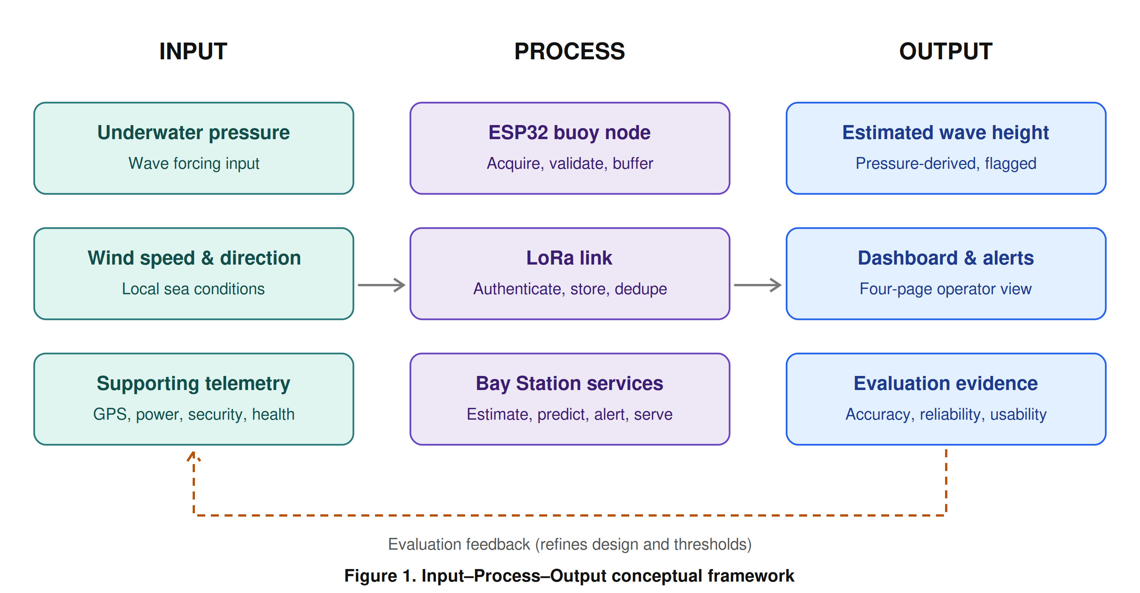
Figure 1. Input–Process–Output conceptual framework
The system is organized into five cooperating layers, each with an explicit responsibility and a defined failure behavior (Table 2). The buoy data is routed through a site-tested LoRa link to a barangay-hall gateway, and SIM/4G/5G is used only as the Bay Station Internet backhaul — never as the buoy direct connection. This separation lets local ingestion, storage, prediction, and dashboard services continue during Internet interruption (see Figure 2), a resilience property emphasized in recent integrated marine-IoT work (Cho et al., 2021; Rojas et al., 2025).
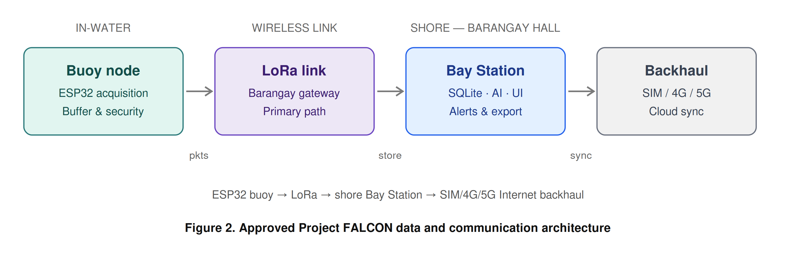
Figure 2. Approved Project FALCON data and communication architecture
Table 2. Approved Project FALCON Data and Communication Architecture
Layer | Responsibility | Failure behavior
Sensors and interfaces | Produce primary pressure/wind signals and supporting telemetry | Report invalid/unavailable states; do not substitute zero
ESP32 buoy node | Acquire, timestamp, validate, frame, secure, transmit, buffer | Continues sensing and local security during LoRa loss
LoRa link | Carry compact packets to the barangay-hall gateway | Triggers buffering and timestamp-preserving retransmission
Bay Station | Authenticate, deduplicate, store, process, predict, alert, serve | Continues local operation during Internet loss
Internet backhaul | Cloud synchronization and authorized remote access only | Queues upload while local services remain available

2.3 Data Collection Methods
Data collection combines primary field data from the deployed prototype with secondary documentary data from datasheets, standards, and official meteorological references.
Primary data. The buoy acquires three classes of data. Underwater pressure is sampled at a rate justified by the target wave band, since pressure-based wave measurement is valid only when attenuation, sensor depth, and frequency response are handled correctly (Meulé et al., 2024; Zhou et al., 2025). Wind speed and direction are acquired through the prototype anemometer/vane assembly, and supporting telemetry — GPS position/time, battery/solar status, enclosure/security state, and system health — is acquired at independent, documented rates. Every record is assigned a station identifier, packet/sequence number, original sample timestamp, firmware/schema version, source label, and quality flags before transmission.
Secondary data. Documentary sources include the pressure-sensor datasheet and immersion guidance (Holykell, n.d.; Blue Robotics, n.d.) and official weather terminology used to frame safety boundaries without implying official forecasting (PAGASA, n.d.).
Reference and calibration instruments. Accurate evaluation requires an independent, time-aligned reference rather than the readings of the system itself. Before controlled trials, the pressure and wind channels are calibrated and the resulting coefficients versioned and recorded. Documentation follows the principle that sensor drift, corrosion, power limits, intermittent communication, and limited references are recurring threats to ocean-sensor data quality; the protocol therefore records metadata, quality flags, and maintenance history alongside raw values (Skålvik et al., 2023).
Data management. A single unified record schema is enforced end-to-end. Out-of-range, stale, disconnected, implausible, and stuck values are flagged or rejected, never silently replaced with zero. During LoRa outages the node buffers a defined duration of records and preserves original timestamps on retransmission; the Bay Station authenticates buoy identity, prevents duplicate insertion, and logs rejected or malformed packets. Data are retained with backups, export capability, and a documented retention rule (Section 2.7).

2.4 Software and Tools Used
The prototype integrates embedded firmware, a shore-side service, a relational database, a web dashboard, and a machine-learning pipeline. Table 3 maps each functional area to the software and tools applied and to its purpose. Following the integrated-evaluation principle of prior marine buoy systems, marine sensing, communication, and battery behavior are treated as one evaluation unit (Cho et al., 2021; Wiranata & Widodo, 2026).
Table 3. Software and Tools Used in Development
Functional area | Software / tool | Purpose
Buoy firmware | ESP32 environment (PlatformIO/Arduino) | Acquisition, timestamping, framing, buffering, LoRa transmission
Shore service | Python (Bay Station service) | Ingestion, validation, deduplication, processing, prediction, API
Database | SQLite | Local storage of original and derived records with version metadata
Dashboard | Responsive web front end (four pages) | Overview, Buoy Motion, Sensors, Logs & Alerts for non-technical operators
API services | REST/grouped endpoint layer | Serve dashboard and export requests; least-privilege access
Prediction | Python machine-learning libraries | Persistence/moving-average baselines and linear, tree-based, GRU, or LSTM candidates
Version control | Git repository | Firmware, schema, algorithm, and model versioning
Mechanical design | CAD software | Buoy geometry, stability, enclosure documentation (reference only pending redesign)

The dashboard navigation is fixed at four pages — Overview, Buoy Motion, Sensors, and Logs & Alerts — with GPS grouped under Supporting Telemetry and Settings kept as a compact header control. Large text, plain labels, and explicit source/freshness states serve older or non-technical operators (Mohammadi et al., 2024). The existing dashboard prototype is shown in Figure 4; any values displayed in simulator mode are not field measurements.

2.5 Development Procedures
Development proceeds through six approval-gated milestones (Table 4), each with a deliverable and an exit-evidence requirement so that no later stage builds on an unverified earlier stage.
Table 4. Development Milestones and Exit Evidence
Milestone | Deliverable | Exit evidence
M1 Scope freeze | Signed architecture, site/use case, wave statistic, AI target | Adviser approval record
M2 Component freeze | Exact BOM, datasheets, pinout, LoRa/Bay Station selection | Selection register complete
M3 Bench integration | Calibrated sensors and packet path | Bench logs and acceptance sheets
M4 Controlled water test | Wave-reference, wind, security, power dataset | Traceable synchronized records
M5 Software evaluation | Dashboard usability and AI baseline/model results | Metrics and held-out evaluation
M6 Final revision | Thesis, presentation, BOM, diagrams, dataset, limitations | Adviser-approved release

Hardware baseline. The pressure channel is the highest-risk component. The deployment candidate is a HPT604 Type A, provisional 0–2 mH2O vented-gauge sensor with 4–20 mA output, interfaced through a protected 12 V loop, a 150 Ω precision shunt, input protection/filtering, and a 3.3 V ADS1115 receiver. Its vent tube must terminate in a dry, breathable, supplier-approved desiccant/breather arrangement, and written confirmation of continuous saltwater compatibility, wetted materials, seals, cable, and exact order code is required before purchase. The bench-only Bar02 I2C sensor is retained only for bench work because its manufacturer restricts continuous immersion (Blue Robotics, n.d.). Final LoRa radio, gateway, antenna, band, and protocol, as well as the Bay Station computer, remain selection gates.
Pressure-to-wave processing procedure. Before implementation is frozen, the researchers define whether the primary output is instantaneous peak-to-trough height, mean height, or significant wave height (Hs). The recommended research output is estimated significant wave height over a stated window, because that term can be defined, aggregated, compared, and predicted consistently. The procedure then freezes sampling frequency, window duration, density assumption, static/tidal removal, filter band, depth-response correction, gap policy, and reference method (Figure 3). Dynamic surface-wave reconstruction requires documented treatment of sensor depth and frequency-dependent attenuation (Meulé et al., 2024; Zhou et al., 2025), with instrument validation against an independent reference as done for encoder/accelerometer wave instruments (Suwardiyanto et al., 2024). All coefficients and revisions are versioned, and where calibration is incomplete the dashboard must display ESTIMATED and CALIBRATION REQUIRED.
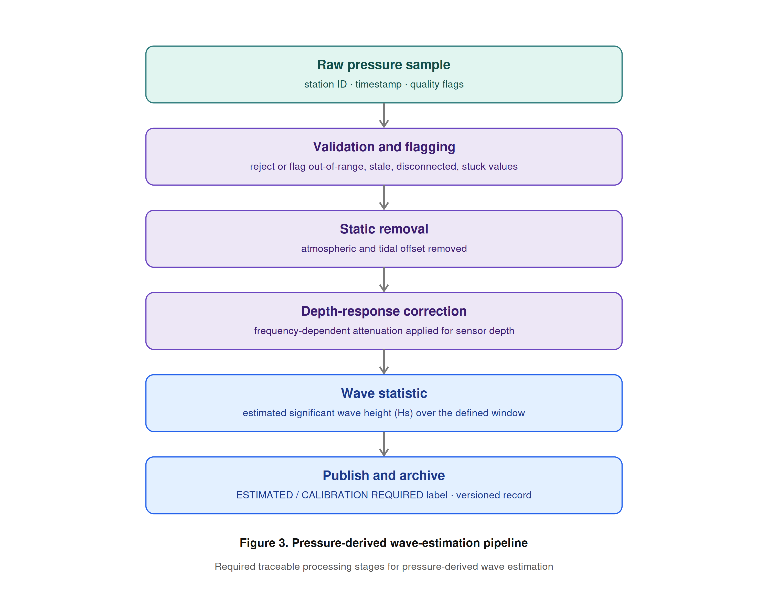
Figure 3. Pressure-derived wave-estimation pipeline
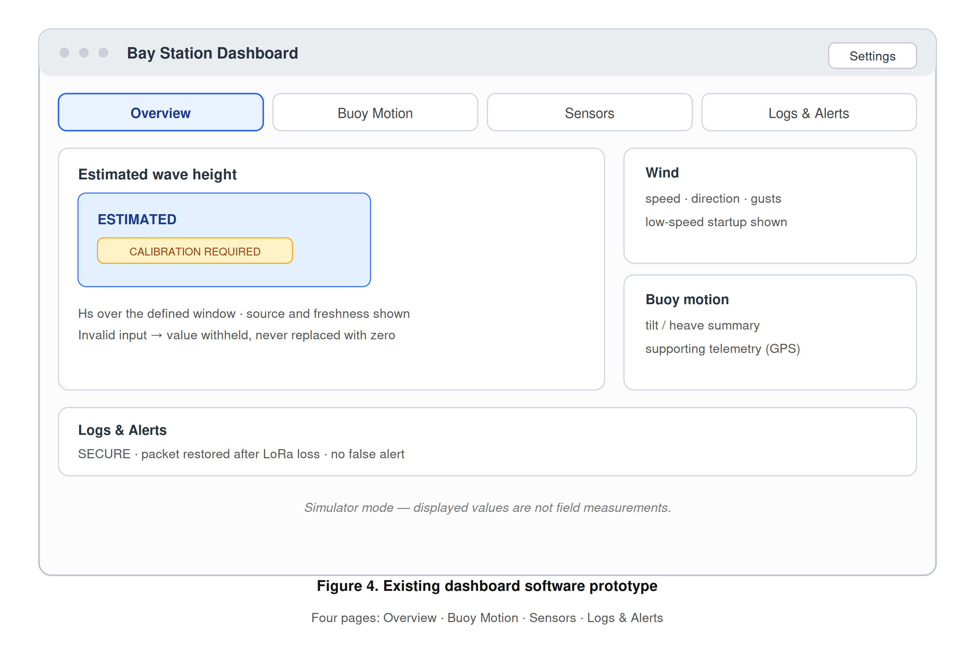
Figure 4. Existing dashboard software prototype
AI prediction procedure. One primary target is frozen — recommended as 10-minute-ahead estimated Hs — subject to adviser and stakeholder approval. Persistence and moving-average baselines are built before any linear, tree-based, GRU, or LSTM candidate is tested (Mo et al., 2024); data are split chronologically by deployment block or day, never by randomly mixing adjacent samples; and prediction is withheld whenever pressure input is invalid, stale, or uncalibrated, while monitoring continues if the AI component fails.
Energy, mechanical, and security procedures. A preliminary energy-budget worksheet (e.g., a 12.8 V, 20 Ah battery at 80% usable capacity against a 4 W average buoy load) is treated explicitly as a calculation, not a measurement, and is replaced by logged current data once hardware is frozen, consistent with energy-balance assessment for solar-powered IoT buoys (Wiranata & Widodo, 2026). The separate buoy and shore power boundaries are illustrated in Figure 5. The replacement mechanical design must pass buoyancy, freeboard, center-of-gravity, stability/righting, tower load, mooring, corrosion, cable strain, ingress, condensation, sensor exposure, antenna clearance, retrieval, and serviceability review. Physical security uses SECURE, WARNING, ALERT, and DISARMED states, with geofence radius, GPS-quality limits, persistence time, maintenance controls, and tamper debounce documented.
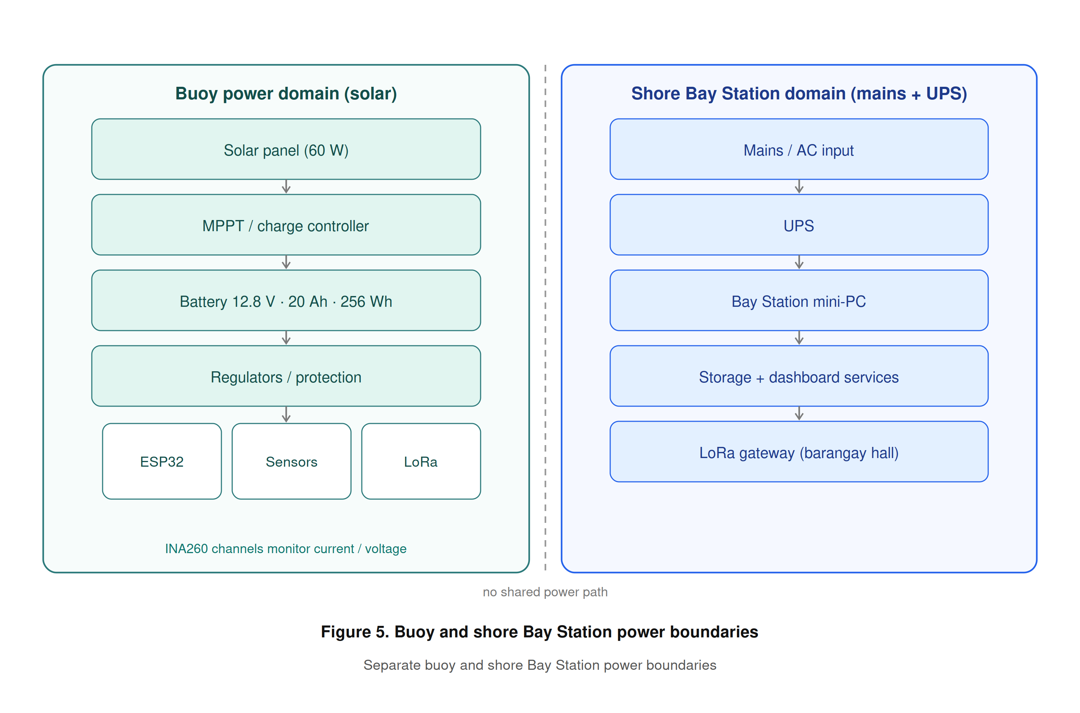
Figure 5. Buoy and shore Bay Station power boundaries

2.6 Testing and Evaluation
Evaluation is organized by area, each with primary metrics and an explicit release condition (Table 5). The evaluation is whole-system rather than component-by-component alone, in keeping with the central claim that honest integration and evidence is where the contribution lies (Figure 6).
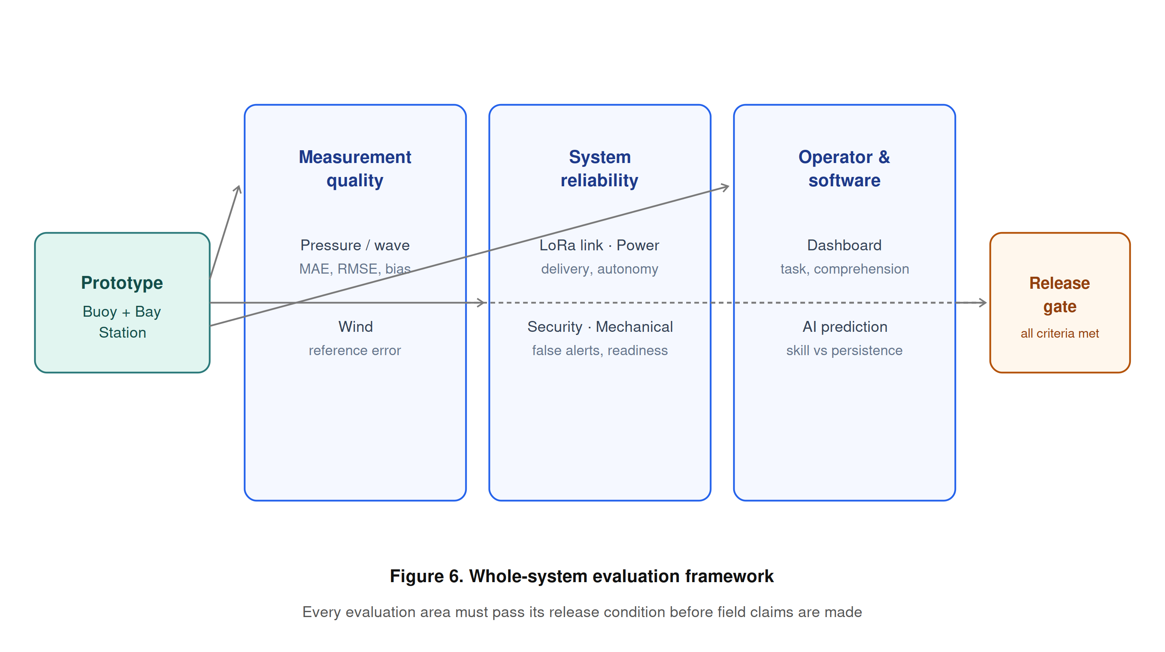
Figure 6. Whole-system evaluation framework
Table 5. Whole-System Evaluation Matrix
Area | Primary metrics / evidence | Release condition
Pressure / wave | MAE, RMSE, bias, repeatability, gaps, comparison plots | Defined wave statistic and accepted reference performance
Wind | Reference error, direction code, low-speed startup, repeatability | Acceptance limits approved and met
LoRa / backhaul | Packet delivery, latency, range, reconnect, duplicates, backlog recovery | Site path works under expected conditions
Power | Average/peak load, Wh/day, autonomy, reduced-sun recovery | Measured margin meets deployment target
Security | True/false alerts, detection delay, GPS scatter | False-alert behavior acceptable
Dashboard | Task completion, errors, time, comprehension, readability | Adviser-approved usability threshold met
AI | MAE/RMSE/bias, skill vs persistence, latency, availability | Improvement on untouched chronological test data
Mechanical | Stability, ingress, corrosion control, retrieval inspection | No unsafe or unresolved critical failure

Statistical treatment. Sensor accuracy is reported using mean absolute error (MAE), root-mean-square error (RMSE), and bias against the independent reference, with repeatability (standard deviation) and percentage error. Communication is summarized by packet-delivery ratio, latency, reconnection time, duplicate count, and backlog-recovery time. Prediction performance reports MAE, RMSE, bias, skill relative to persistence, inference time, model size, missing-input behavior, and error by sea-condition range, with uncertainty based on observed residuals rather than an arbitrary confidence percentage (Bekiryazıcı et al., 2025; Chan et al., 2026).
Test scenarios. Controlled scenarios verify fault and recovery behavior (Table 6), ensuring that abnormal conditions surface as explicit, logged states rather than as silent failures or fabricated values.
Table 6. Controlled Test Scenarios
ID | Scenario | Expected observable behavior
P-01 | Pressure disconnected or implausible | Wave estimate and AI withheld; fault logged; no fabricated zero
C-01 | LoRa link interrupted | ESP32 buffers timestamped packets; retransmits without duplicate insertion
I-01 | Bay Station Internet interrupted | Local ingestion, storage, prediction, dashboard, alerts continue
G-01 | GPS scatter near geofence boundary | WARNING persistence prevents immediate false ALERT
T-01 | Enclosure opened while armed | Persistent event produces logged ALERT; maintenance DISARMED distinct
A-01 | AI model unavailable | Measured/estimated monitoring remains operational; prediction shows unavailable
B-01 | Low battery / reduced sunlight | Power warning, safe operating policy, and recovery are logged
R-01 | Bay Station restart | Services start automatically and stored records remain intact

Usability testing. Evaluators are given realistic tasks — identify the current wave estimate, verify GPS/security state, find a stale sensor, acknowledge an alert, and export records. The testing records task completion, completion time, navigation errors, assistance required, and label comprehension, and collects readability and confidence ratings using an adviser-approved usability instrument and sample. Because GNSS-based observations are useful only with appropriate processing and reference comparison (Knight et al., 2021), position data are interpreted with fix quality and persistence, and an isolated coordinate is never by itself treated as theft. The research instrument undergoes expert validation with a certificate of validation obtained before data gathering.

2.7 Ethical Considerations
Site, permits, and safety. Deployment requires written permission from the responsible site authority (e.g., the barangay or local government unit) and navigational and environmental review. Field work observes safe battery and electrical handling, defined weather limits, retrieval planning, and unambiguous prototype labeling so the public cannot mistake the buoy for an official installation.
Human participants. Usability participants — including older or non-technical operators — provide informed consent, and only the minimum necessary data are collected. Participants may withdraw at any time, and no personally identifying information is published without permission.
Public safety and honesty. The system must never issue or imply official warnings; operators are directed to PAGASA and competent authorities for all safety decisions (PAGASA, n.d.). The thesis maintains strict vocabulary discipline: pressure-derived output is presented only as estimated wave height, the AI output only as a research prediction, and simulator results are never described as physical measurements.
Data privacy and security. GPS locations are disclosed only to authorized users where a deployment partner regards them as sensitive. Cybersecurity controls include per-device identity, replay/duplicate protection, least-privilege operator access, TLS for Internet traffic, and audit records, protecting both the data and the individuals and communities associated with the deployment site.
Research integrity and environmental care. Intellectual honesty is enforced through version control of firmware, schemas, algorithms, and models; full retention of raw and processed data with quality metadata; and explicit documentation of limitations. Field activities minimize environmental disturbance, and all retrieved hardware and batteries are handled and disposed of responsibly.

